**Diabetes Classification**

**Introduction**

The objective of this project is to build a classification model for predicting the likelihood of diabetes based on various health-related features. The dataset used in this study is sourced from Kaggle and contains detailed information on individuals, including features such as glucose levels, blood pressure, BMI, and age. The primary goal is to explore the effectiveness of different classification algorithms, including k-Nearest Neighbors (KNN), Random Forest, Support Vector Machine (SVM), Decision Tree, and Naive Bayes, in predicting diabetes status. The project aims to provide valuable insights into the strengths and limitations of different classification algorithms for classifying diabetes. The findings will contribute to the ongoing discussion on the application of machine learning in healthcare, specifically in the context of early diabetes detection. The results may have implications for improving healthcare strategies and resource allocation, ultimately enhancing the overall effectiveness of diabetes prevention and management.

**Methodology:**

**Data Collection and Preprocessing:**

* Dataset sourced from [Kaggle](https://www.kaggle.com/datasets/uciml/pima-indians-diabetes-database/), encompassing comprehensive information on individuals.
* Features include pregnancies, glucose, blood pressure, skin thickness, insulin, BMI, diabetes pedigree function, and age.
* Target variable: Diabetes status, coded as binary (0 for non-diabetic, 1 for diabetic).
* Preprocessing steps focused on meticulous handling of missing values in the dataset.
* Numerical feature scaling or normalization was applied for uniform model performance.
* Categorical variable encoding was executed to ensure compatibility with selected classification algorithms.
* Exploratory data analysis (EDA) techniques, such as histograms and correlation matrices, were employed to gain insights into dataset characteristics.
* EDA facilitated the identification of patterns and relationships among features, aiding in model interpretation.
* Class distribution analysis during EDA helped identify potential imbalances between diabetic and non-diabetic cases in the dataset.
* The rigorous preprocessing approach set the foundation for reliable data, contributing to successful model training and evaluation for accurate diabetes prediction.

**Model Building:**

1. **Classification Algorithms:** Utilizing a diverse array of classification algorithms, namely K-Nearest Neighbors (KNN), Random Forest, Support Vector Machine (SVM), Decision Tree, and Naive Bayes, adds robustness to the model. Each algorithm brings unique strengths and characteristics that contribute to the overall effectiveness of the diabetes prediction task.
2. **Training and Testing Sets**: The dataset underwent a systematic division into training and testing sets, maintaining a 70:30 ratio. This strategic split ensures that the model's performance is rigorously assessed on unseen data, helping to gauge its generalization capability. The training set is used to train the model, while the testing set serves as an independent validation to evaluate how well the model can make accurate predictions on new, previously unseen instances. This approach is fundamental for estimating the model's real-world performance and reliability.

**Model Evaluation:**

1. **Performance Metrics:**We utilized a comprehensive set of metrics, including accuracy, precision, recall, and F1-score, to thoroughly evaluate the models. These metrics provide a holistic understanding of the models' effectiveness in predicting diabetes status.
2. **Algorithm Comparison:** The performance of each classification model was carefully compared. This evaluation sought to determine the best technique for estimating the presence of diabetes while highlighting the advantages and disadvantages of each algorithm.
3. **Result**: A number of measures were used to gauge how well different categorization algorithms performed in predicting a person's diabetes status. This analysis took into account the Random Forest, Naive Bayes, Support Vector Machine (SVM), Decision Tree, and k-Nearest Neighbors (KNN) algorithms. Performance indicators like accuracy, precision, recall, F1-score were computed for KNN, Random Forest, SVM, Decision Tree, and Naive Bayes. We have also performed K-Fold ( 5-fold) validation for each classification model for validating the outcome. Considering all aspects, we found Random Forest as the best classifier from our analysis.

**Practical Applications:**

Our classification program offers significant benefits in healthcare:

* Clinical Diagnosis: Enables early identification of diabetes risk, facilitating prompt intervention and targeted treatments for better patient outcomes.
* Personalized Healthcare: Generates individual risk predictions, allowing tailored recommendations and interventions, enhancing patient-centric healthcare delivery.
* Public Health Planning: Provides insights for optimizing resource allocation, directing preventive measures, and designing targeted initiatives to address the broader public health challenge of diabetes.

Our classification system provides a complete answer to the practical problem of diabetes. It facilitates early diagnosis in clinical settings, which lowers healthcare costs and allows for prompt interventions and better patient outcomes. The tool enhances treatment efficacy for personalized healthcare by enabling precision medicine by customizing suggestions based on individual risk estimations. When it comes to public health planning, it offers data-driven insights that help policymakers target interventions, manage resources effectively, and create awareness campaigns that effectively address the larger problem of diabetes at the individual and population levels.

**Conclusion:**

The high accuracy of the Random Forest model implies that it can be a valuable asset in public health initiatives and healthcare planning. Efficient diabetes prediction models enable healthcare professionals and policymakers to identify individuals at risk more accurately, facilitating targeted interventions and resource allocation. This, in turn, can lead to more cost-effective healthcare strategies and improved patient outcomes. The project's contribution to advancing efficient diabetes prediction techniques not only enhances the understanding of machine learning applications in healthcare but also opens avenues for future research and development. The success of Random Forest in this context underscores the importance of exploring and fine-tuning various machine learning algorithms for specific healthcare tasks, tailoring approaches to the unique characteristics of medical datasets.

Ultimately, the project's findings offer a step forward in leveraging machine learning for proactive diabetes management, contributing to the broader goal of improving public health outcomes and optimizing healthcare resources.

**Appendix:**

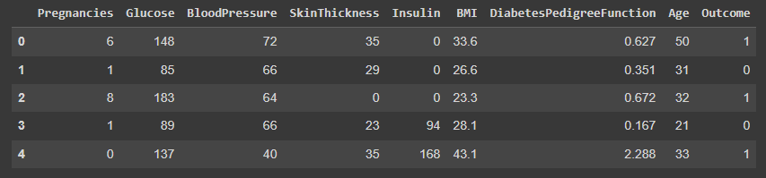

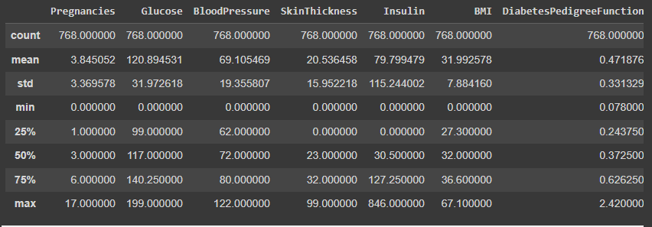

**Fig 1:** Dataset

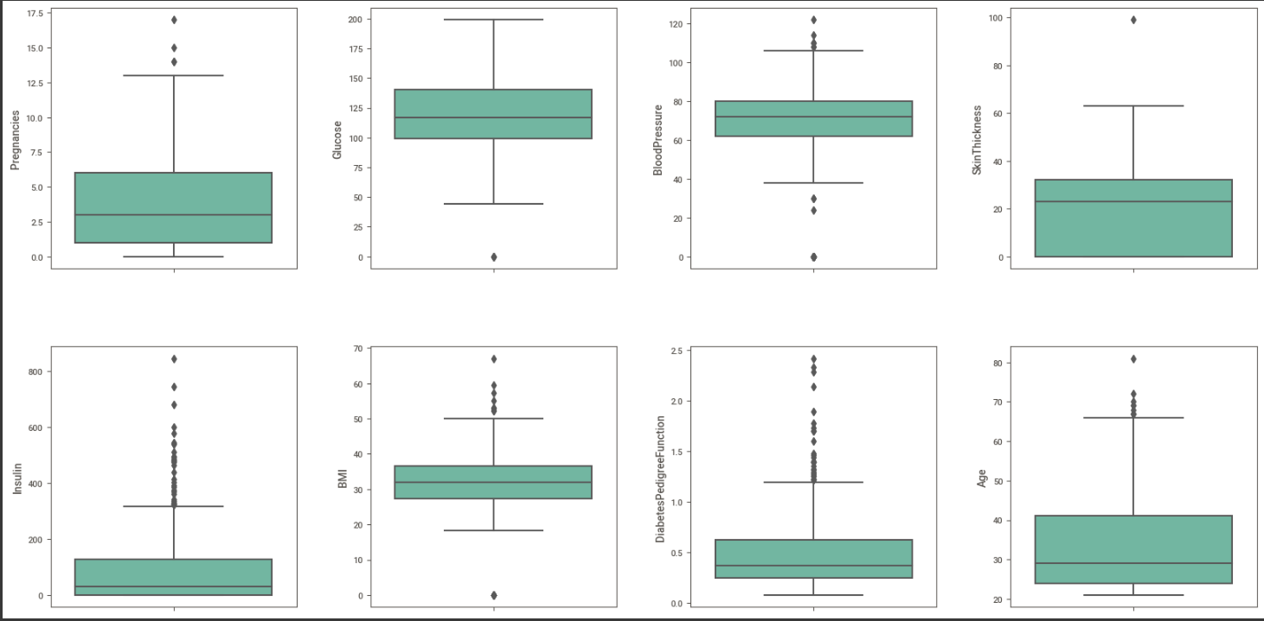

**Fig 2:** Data Visualization

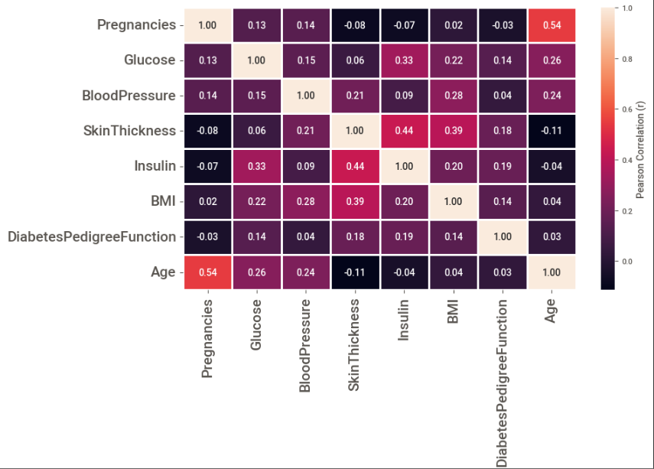

**Fig 3:** Correlation Matrix

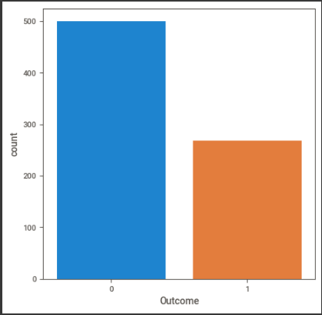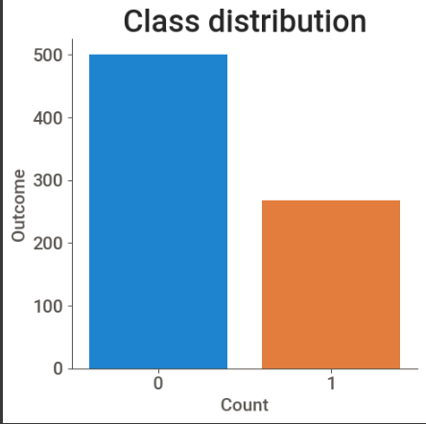

**Fig 4**: Class Distribution

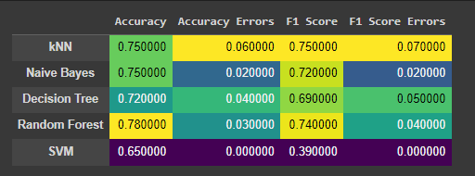

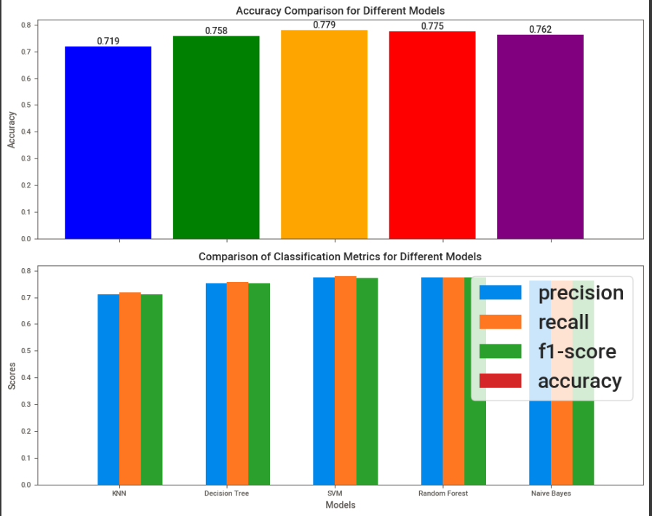

**Fig 5:** Performance Analysis